**Lab 6 : Trie Data Structure - Part II**

**Compressed Tries (Radix Tree)**

**E/13/056**

2. Measure time to generate suggested word list for word “the” in both scenarios.

Scenario 1 – Regular Trie

Time = 0.002638

Scenario 2 – Radix Trie

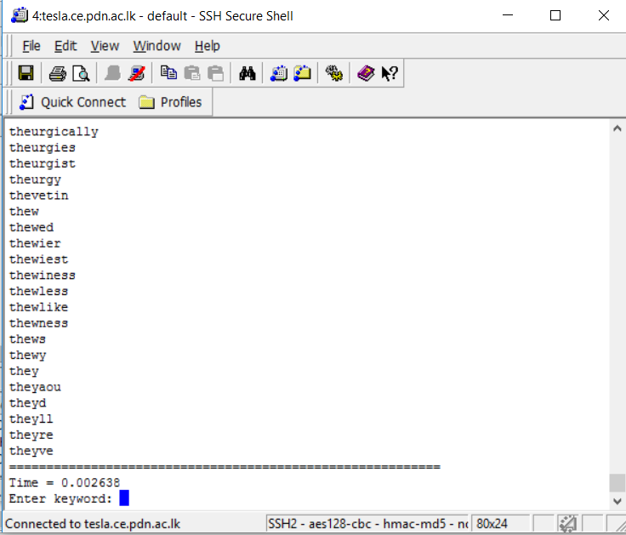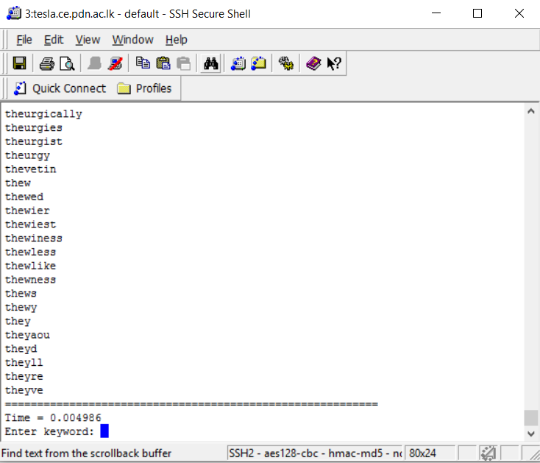 Time = 0.004986

3. Memory consumptions of a regular trie and a Radix Tree.

Memory Consumption of a Regular trie is higher than Radix tree. Because one node require to a one character in regular trie. But in Radix tree more than one character can be put. So no of nodes needed for radix tree is less than Regular tire.

Time Consumption of radix tree is higher than regular trie, because insert of radix tree is more complex, it will take more time, but search in radix tree is less than regular trie.

In my radix tree code I insert as a regular tree and after that compressed it to a radix tree, so it will take more time to insert.